3G150B-How to upgrade the firmware
Product line: 3G Question category: Function configarations

Q: Why we need to upgrade firmware for 3G150B?
A: Sometimes we may need to Upgrade the router to another firmware version if the current firmware version can no longer satisfies your requirement. For example, the new firmware will be of great valve to fix some bugs and to achieve better service.
Warning:
1. Upgrade with Ethernet cable, do not upgrade wirelessly, it may cause failure and damage the router.
2. Keep Power on the router when upgrading.
3. Don’t upgrade remotely, please just directly connect your PC and router and perform the upgrade.
4. Please make sure you upgrade into a right firmware version. Wrong updates will damage your router.
The topology is as below:

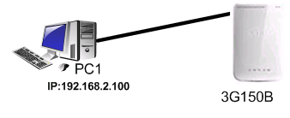
Steps are as following:
1. Download the correct firmware from our web site www.tendacn.com to your computer.
2．Please connect your computer to the port of the 3G150B with an Ethernet cable, power on your devices.
3．Login the management page of the router. (The default IP is 192.168.2.1, password is admin).
4．Click System Tools->Upgrade, then click Browse to Locate and select the firmware, then click Upgrade button to upgrade the firmware for the router. The router will reboot after finish upgrading.
